Project Cinema System

# Goals

The goal of the project is to develop a cinema management system, this system will let users buy tickets, follow cinema schedules ,and book a film..

# System description

Your system must have the following main functions:

1. The system records all cinema rooms with room ID, name, number of seats identified by number of rows and number of columns.

2. The system records all films with film ID, title, producer year, and description. Each film is categorized by genre and country. So the system also records movie genre information (including genre ID, genre name, and description) and country information (including country code, country name).

3. A film will be shown in a room at a time slot of the day. Status of a show may be available or not available (closed) for booking.

4. Booking information for each show will be recorded, including customer name, several booked seats identified by row number and column number.

# SRS overview

## 2.1 List of system users

## 2.2 List of use cases

## 2.3 Use case diagram

### 2.3.1 Preliminary use case diagram

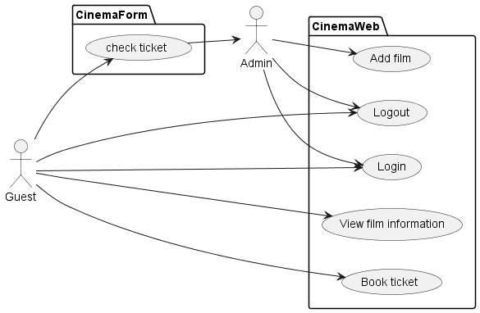

### 2.3.2. Use case detail diagrams

#### 2.3.2.1 Use case add film for admin

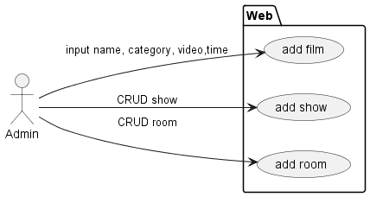

#### 2.3.2.2 Use case booking ticket

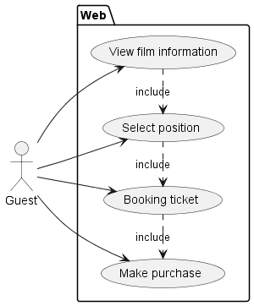

#### 2.3.2.3 Use case checking ticket

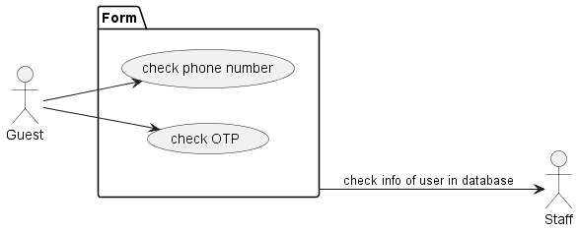

## 2.4 Activity diagrams of use case scenarios

### 2.4.1 Activity diagrams for user booking ticket

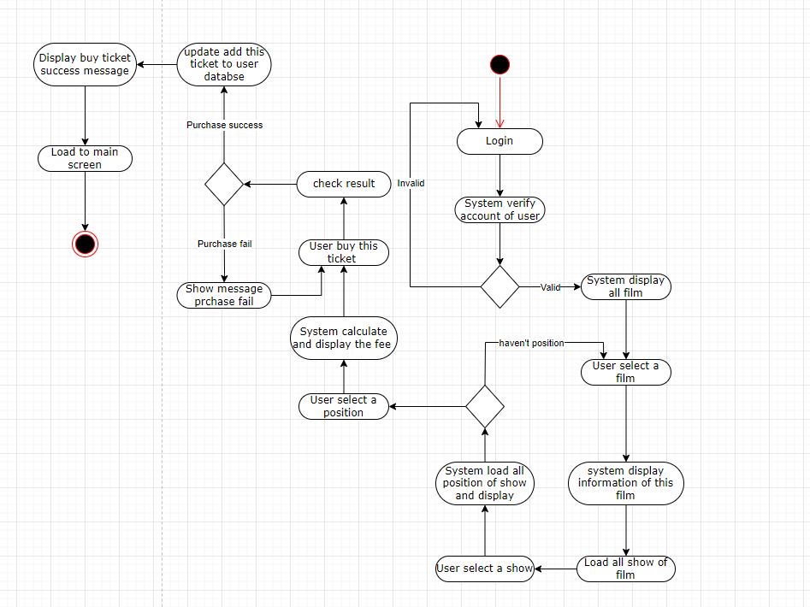

### 2.4.2 Activity diagrams for admin check ticket

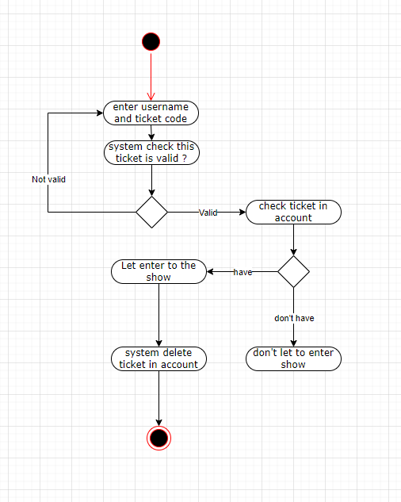

### 2.4.3 Activity diagrams for user login

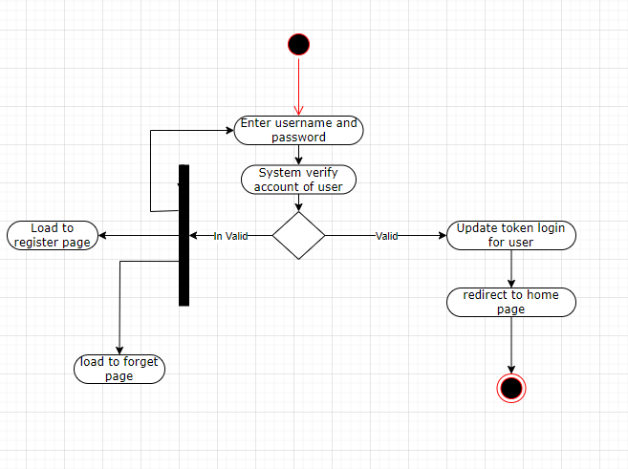

### 2.4.5 Activity diagrams for admin add new show

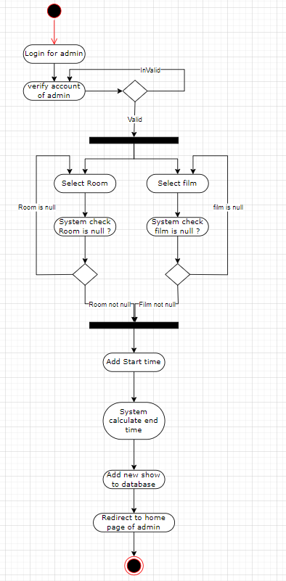

### 2.4.6 Activity diagrams for user update information

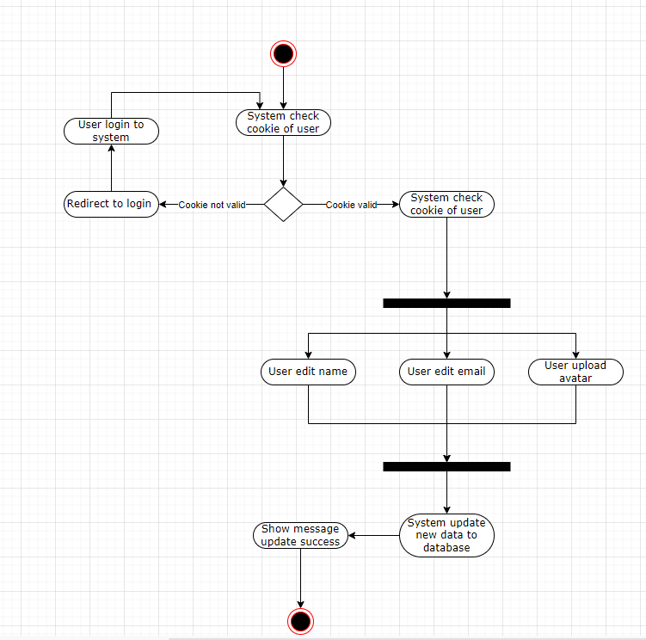

# Data model

## 3.1 Entity Relationship Diagram

